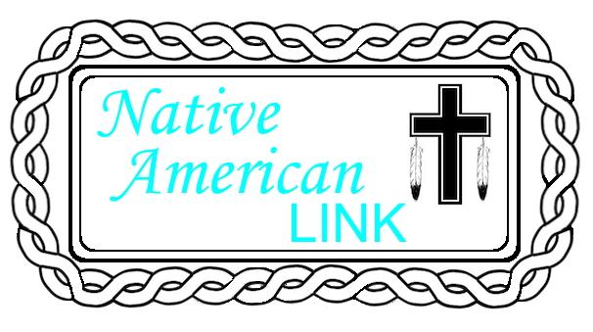
Augusta Smith, Executive Director
P. O. Box 470974
Tulsa, OK 74147
NativeAmericanLINK@gmail.com
918-931-2218
Website: TheNativeAmericanLINKInc.org

Dear Pastors, WMU Leaders & Friends of The Native American LINK,

We pray you will encourage the men and women of your church will consider participating in the Willene Pierce Memorial Conference, sponsored by The Native American LINK, Inc. The conference will be held at Glorieta Baptist Church, Oklahoma City, Oklahoma on March 19-21, 2015.

Willene became acquainted with our people, first coming to Oklahoma from Kansas with her grandmother as a young girl, assisting with Vacation Bible School among Choctaws in southeast Oklahoma, then returning again as a teenager, then as a college student at Oklahoma Baptist University. Her best friends in college were Indian students, joining the Indian Club, and even joining Sallateeska Baptist Church, an Indian congregation.

Willene kept our people in her heart, answering God’s call to return to Oklahoma in 1998 to begin the LINK ministry. Although it began as a women’s Christian ministry, the work of the organization places focuses on family, leadership & spiritual development.

Willene Pierce left us on March 18, 2014, completing God’s calling for her life. She has left a rich legacy in the hearts of many who knew her. The LINK ministry wishes to host this conference, designed for both men and women, nation-wide, Native and Non-Native, as a fitting tribute to her vision for our Native American people. Conference speakers, those who share testimonies, and workshop leaders include individuals who knew Willene personally, and the workshops are designed for spiritual growth. She continues to impact us today.

We will have tribal singing, purposeful workshops and ministry projects, and many wonderful worship experiences. I pray you will join us for this special tribute to Willene.
In His Service,
Augusta Smith (Gus)
Executive Director

The Willene Pierce Memorial Conference
A Conference Designed for Women & Men
Date: March 19-21, 2015
Place: Glorieta Baptist Church
7308 S. Western Ave.
Oklahoma City, OK 73139
Hosted by: The Native American LINK Inc.

Keynote Speakers: Carol Causey, WMU-Birmingham, Ms. Patsy Davis, BWA-Women’s Department, Dr. Emerson Falls-BGCO Native American Specialist, and Rev. Ward & June Holland, Maryland/Delaware Baptist Convention.

Music Ministry directed by Shirley Falls. Praise Team: Connie Foreman, Wayne & Lucille Harjo, Instrumentalists: Robert Deere & Dylan Mateo. Special Music: Pam Wesley, Shirley Falls, & Native Praise Choir.
Testimonies will be provided by friends and co-workers of Willene Pierce during her many years of ministry.

Focus Areas of Conference Sessions
Christian Communication through Social Media – Rendon Falls
Christian Parenting – Bryce Scott
Failing, Fallen, Forgiven…Serving – Alan Washington
Getting the Most Out of Bible Study – Carol Causey
Grandparents Raising Children (Again) – Florence July
Guarding Your Temple – Ben Little
Human Trafficking/Post Traumatic Stress Disorders –Pat Wagstaff & Wanda Lively
Kick Start to Good Health among Native People – Donna Drew
Living Life Without My Spouse – Linda Hummingbird
Living the Single Life with God – Taryn Anquoe
Missions & Me – Rachel Hamblin
The Christian & Money Management – Emerson Falls

Ministry Projects-Friday afternoon will be an opportunity to participate in various ministry projects. For those who are able, we will be collecting disposable baby diapers and baby wash cloths. Crafts sessions will also be available.

Tribal Singing-Each worship session will highlight congregational tribal singing. Thursday evening-Choctaw & Chickasaw;
Friday morning-Cherokee; Friday evening-Creek/Seminole. We welcome additional tribes to participate throughout the conference. If your tribe is not listed and you wish to participate, please contact Shirley Falls; shirleyafalls@gmail.com or Phone: 405-684-6795. We encourage tribal dress (men & women) in our Thursday evening opening session.

Awards - We will present awards during Saturday morning session for:
Churches/individual(s) for greatest distance traveled
Churches with highest attendance
Churches with pastors in attendance

Hotel Accommodations near Glorieta Baptist Church:
Best Western PLUS Barsana Hotel & Suites Hampton Inn-Suites Oklahoma City-South Comfort Inn
7701 CA Henderson Blvd. 920 SW 77th Street 7601 C.A. Henderson Blvd.
Oklahoma City, OK 73139-2422 Oklahoma City, OK 73139 Interstate-240 & C.A. Henderson
Tel: 405/601-1200 405-602-3400 Oklahoma City, OK 73139
405-631-3111
Special Rate: $79+tax
Willene Pierce Memorial Conference
Group code: 2025218
3/19/2015-3/21/2015
Reservation Deadline: March 5, 2015

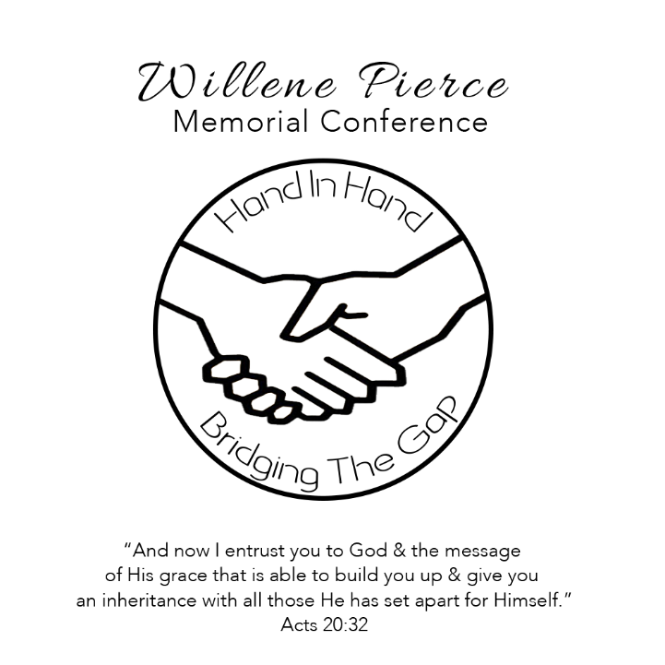
Registration
Name__________________________________________________________________________________
Address________________________________________________________________________________
City________________________________________________ State____________ Zip Code___________
Phone: __________________ Email: _________________________________________________________
Age Range: 18-24 25-34 35-49 50-65 66+older Gender: Male Female
Church Name __________________________________________________________________________
City_____________________________________________________ State_________________________
Tribal Affiliation(s) ______________________________________________________________________
Please return registration form before March 1, 2015 with Pre-Registration Fee of $40 payable to:
The Native American LINK, Inc., P. O. Box 470974, Tulsa, OK 74147. After March 1, 2014, or at door, registration fee will be $45. Payment of registration includes bag, program, promotional items, notepad, & pen. Included are meals for Thursday dinner, Friday lunch & dinner, and Saturday lunch. Breakfast on your own.

For those who cannot attend entire conference: Cost for one general session ($5) Thursday PM, Friday PM or Saturday AM; or one-day-Friday ($20)
Transportation will be provided for those arriving from the airport. (Arrival at airport, Transport to Hotel, Transport to Church facility, and Return to Airport for Departure Flight.) Please specify, if needed.
Feel free to duplicate this form for other participants, as needed.
Questions? Contact Augusta Smith, Director Phone: 918-931-2218 or email: nativeamericanlink@gmail.com
Registration form also available on The Native American LINK, Inc. website: www.TheNativeAmericanLINKInc.org
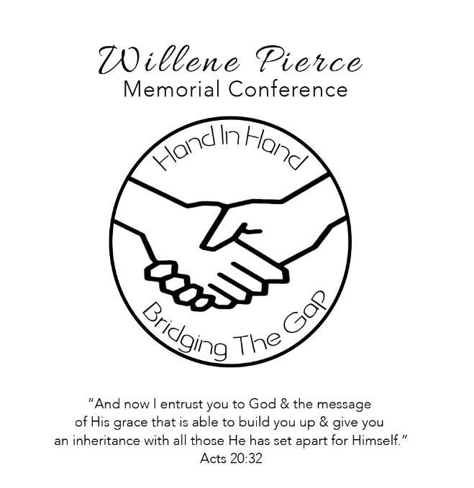
Thursday, March 19, 2015 Saturday, March 21, 2015
3-5:30 PM Registration & Exhibit Displays 9:00 AM General Worship Session
5:30PM Dinner Theme Interpretation
6:45PM General Worship Session Praise Team & Testimonies
Theme Interpretation, Praise Team & Testimonies
Tribal Singing – Choctaw & Chickasaw 9:45 AM Workshop Breakout Guest Speaker: Carol Causey-WMU, Birmingham
Reception following Evening Session 11:00 AM General Worship Session
Praise Team
Friday, March 20, 2015 Native Praise Choir
8:30 AM General Worship Session Special Music
Theme Interpretation, Praise Team & Testimonies Guest Speaker: Dr. Emerson Falls,
Tribal Singing – Cherokee BGCO Native American Specialist
Guest Speaker: Patsy Davis-BWA Women’s Department
10:45 AM Workshop Breakout Sessions Lunch/ Depart for Home

12:00 Noon Lunch

Friday Afternoon Session, March 20, 2015
1:00 PM Ministry Projects for ALL & Crafts Opportunity
Prayerwalking, Prayer Blankets, Baby Packages, Hygiene Kits

4 PM-5:30 PM R & R (time on your own)

5:30-6:45 PM Indian Taco Dinner

Friday Evening, March 20, 2015
7:00 PM General Worship Session
Theme Interpretation, Praise Team & Testimonies
Tribal Singing – Creek & Seminole
Guest Speakers: June & Ward Holland, MD/DE Baptist Convention

